AI-Based Construction Worker Attendance and PPE Compliance Monitoring System

2. Problem Statement
Construction sites present high-risk work environments that require strict adherence to safety protocols, particularly the continuous use of Personal Protective Equipment (PPE) such as helmets and high-visibility vests. Currently, monitoring PPE compliance and managing worker attendance are often performed manually. These methods are labor-intensive, prone to human error, and difficult to scale across large and active construction sites.
This project aims to address these challenges by developing an automated system based on Computer Vision, facial recognition, data management, and Generative AI. The proposed system will automate worker attendance at site entrances, monitor PPE compliance from construction-site video, store and analyze the collected data, and generate daily safety reports.

3. Project Objectives

Main Objective:
To develop and integrate an AI-driven system capable of identifying construction personnel, recording daily attendance, monitoring PPE compliance, and generating automated safety reports.

Specific Objectives:
- Biometric Registration: Develop a secure worker registry that captures facial images and generates biometric embeddings for identification.
- Automated Attendance: Implement a facial recognition pipeline to log gate clock-ins and prevent duplicate records.
- PPE Detection: Train and deploy a lightweight object detection model to identify persons, helmets, and safety vests.
- Worker Tracking: Maintain worker identities efficiently across video frames using object tracking and identity caching.
- Data Centralization: Store all metadata, attendance logs, and PPE compliance events within a structured relational database.
- Automated Auditing: Leverage a Large Language Model (LLM) to aggregate daily database logs into structured, human-readable safety reports.
- Model Evaluation: Conduct rigorous AI evaluation (e.g., mAP, Precision, Recall) to validate the model's reliability on custom datasets.

4. Functional Requirements
Worker Management Subsystem The administrative system must be capable of:
- Registering new workers with relevant metadata (Name, Employee ID, Role, Department).
- Capturing reference facial images and generating facial embeddings for worker identification.
- Optionally assigning unique numerical ID tags for alternative visual identification.
Gate Attendance Subsystem The entry point system must be capable of:
- Processing a video frame to detect a worker's face.
- Comparing the detected face against registered workers to verify their identity.
- Logging the initial clock-in timestamp while preventing duplicate entries for the same calendar date.
Construction Site Monitoring Subsystem The live video processing pipeline must be capable of:
- Detecting persons, helmets, and safety vests within a video frame.
- Tracking workers continuously as they move across the camera's view.
- Associating detected helmets and safety vests with the corresponding worker to determine their PPE compliance status (Full PPE, Vest Missing, Helmet Missing, or No PPE).
- Writing timestamped compliance and violation events directly to the database.
Analytics & Reporting Subsystem The data aggregation engine must be capable of:
- Calculating daily attendance statistics and overall site PPE compliance percentages.
- Identifying missing personnel and categorizing safety violations.
- Generating a formatted daily safety report using Generative AI based on aggregated database statistics.

5. Non-Functional Requirements
Performance Constraints
- The PPE detection model should target a performance of $≥80\%$ mAP on the project’s test dataset.
- The processing pipeline should be designed to run efficiently on available laptop hardware without requiring cloud GPU infrastructure.
Reliability & Robustness
- The system should support scenes containing multiple workers simultaneously.
- The system should be evaluated under varying lighting conditions, different worker orientations, and partial occlusions.
Security & Privacy
- Biometric data and attendance logs must be stored securely within a local database.
- Facial embeddings should be treated as sensitive biometric information and should not be exposed through the user interface.
- Access to the administrative dashboard and generated reports must be restricted to authorized users.

6. Project Scope
To guarantee successful delivery within the 3–4 week internship timeline, the boundaries of the system are defined as follows:
In Scope:
- Worker registration and facial embedding extraction.
- Entrance attendance logging via face recognition.
- Fine-tuning and evaluating a PPE object detection model on a project-specific dataset.
- Continuous worker tracking and PPE compliance evaluation from video feeds.
- Relational database management.
- Automated daily safety report generation via an LLM.
- Basic web dashboard for administration.
Out of Scope / Future Extensions:
- Multi-camera spatial synchronization across a large geographic site.
- Enterprise cloud deployment (e.g., AWS/Azure).
- Native mobile applications for workers.
- Advanced OCR/QR-based worker identification.

7. AI Components & Core Contribution
The system integrates multiple AI disciplines to achieve its objectives, balancing pre-trained backbones with custom fine-tuning.
Component | Technology | Purpose in System
Face Recognition | InsightFace | Generate facial embeddings and identify registered workers.
Object Detection | YOLO | Detect persons, helmets, and safety vests.
Multi-Object Tracking | ByteTrack | Maintain persistent identities across video frames.
Generative AI | LLM API | Generate natural-language safety reports from structured statistics.
Model Development & Evaluation | YOLO + Custom PPE Dataset | Fine-tune, evaluate, analyze errors, and improve the PPE detection model.

Primary AI Engineering Contribution:
Rather than simply integrating pre-trained APIs, the primary engineering contribution of this project is the Machine Learning Lifecycle: the curation of a dedicated PPE dataset, the fine-tuning of the YOLO model, rigorous performance evaluation (mAP, Precision, Recall), systematic error analysis, and the architectural integration of these models into a continuous, functional pipeline.

8. System Architecture
The system architecture is organized into modular components connected through a backend application layer and a centralized PostgreSQL database. This approach promotes modularity, maintainability, secure data flow, and consistent data management.
- Worker Registration Module: Captures administrative input and reference photographs, processes biometric data, and stores the worker's identity profile via the backend API.
- Attendance Pipeline: Ingests frames from the entrance camera, performs facial recognition to verify identity against the database, and logs a daily clock-in record.
- Site Monitoring Pipeline: Ingests live video from construction site cameras. It performs object detection, multi-object tracking, and worker identification to evaluate PPE compliance. Results are transmitted to the backend layer for logging.
- Analytics & Reporting Module: Queries the database to aggregate daily attendance and compliance statistics, formats these metrics into a prompt, and queries a Generative AI model to produce a final safety report.

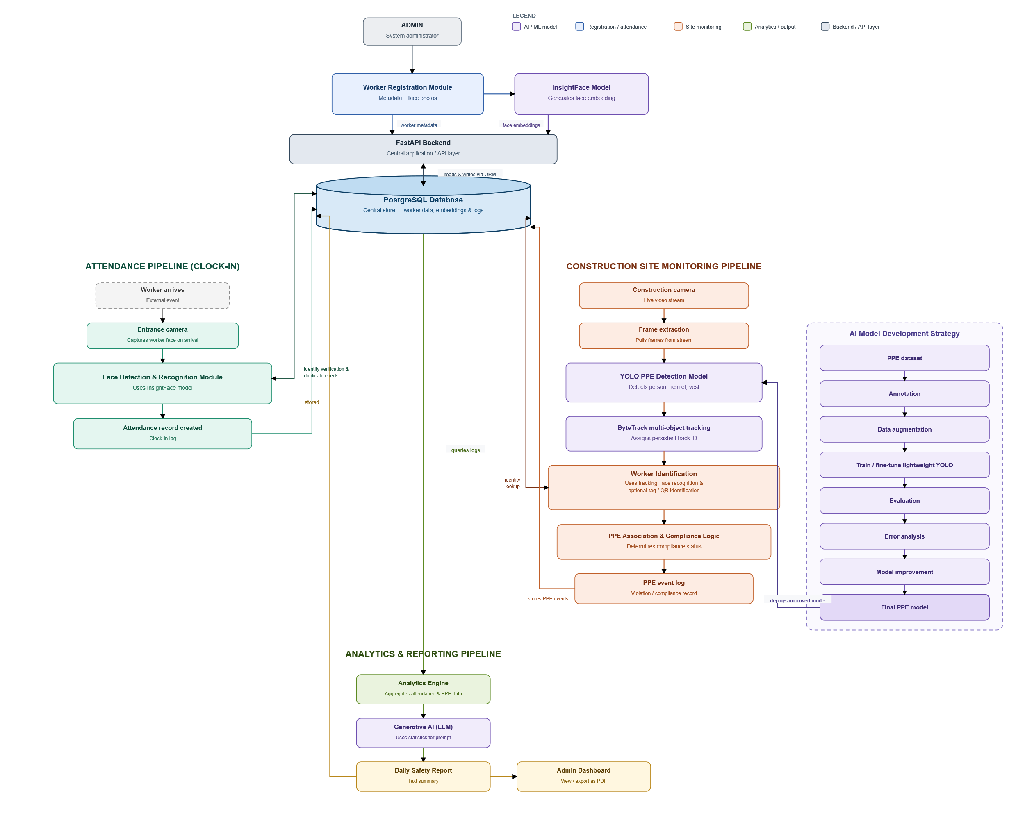

9. Technology Stack
To balance performance with the constraints of a 3–4 week development timeline, the project will utilize the following primary technologies:
- Artificial Intelligence & Computer Vision: Python, PyTorch, YOLO (Object Detection), InsightFace (Facial Recognition), ByteTrack (Multi-Object Tracking), and OpenCV (Image Processing).
- Backend Application Layer: FastAPI (Python) to handle API endpoints and database transactions.
- Database Management: PostgreSQL (with pgvector for storing and searching facial embeddings) for robust, relational data storage.
- Frontend Dashboard: React to provide the administrative user interface.
- Generative AI: LLM (API-based, such as Llama or another suitable model) for automated natural language report generation.
- Deployment Environment: Local execution on available hardware, focusing on functional demonstration rather than cloud-scale production.

10. Data Flow
Data moves through the system in four distinct lifecycles:
- Registration Data Flow: The administrator provides worker details and images $→$ The system generates a facial embedding $→$ Metadata and the biometric embedding are stored in the database.
- Attendance Data Flow: A camera captures a worker's face $→$ The system extracts a live facial embedding $→$ The embedding is matched against the database $→$ A timestamped attendance record is created.
- PPE Monitoring Data Flow: A site camera captures a video frame $→$ The object detection model detects persons, helmets, and safety vests $→$ The tracking system assigns a persistent track ID $→$ The worker’s identity is resolved $→$ Compliance logic determines the PPE status $→$ A timestamped event is written to the database.
- Reporting Data Flow: The backend retrieves all attendance and PPE events for the day $→$ Data is aggregated into summary statistics $→$ Statistics are passed to the Generative AI $→$ The AI returns a formatted textual report for the dashboard.

11. Database Concept
The system relies on a centralized relational database. At the conceptual level, the schema separates metadata from biometric vectors and event logs to ensure query efficiency.
- Workers Entity: Stores worker metadata such as Worker ID, Name, Role, Department, and an optional Tag ID.
- Face Embeddings Entity: Stores the facial embeddings associated with registered workers for high-speed identity verification.
- Attendance Records Entity: Stores the Worker ID, date, clock-in time, and overall attendance status to prevent duplicate entries.
- PPE Compliance Logs Entity: Stores the Worker ID, timestamp, camera ID, detected helmet/vest status, and the calculated overall compliance category (e.g., "Helmet Missing").
- Reports Entity: Stores generated daily safety reports and associated metadata, such as the report date and generation timestamp.
Central Relationship:
Worker ID serves as the central identifier connecting worker information, attendance records, PPE compliance events, and generated safety reports.

12. AI Model Development Strategy
The AI development lifecycle for the PPE detection module will follow industry-standard Machine Learning practices. Rather than developing an architecture from mathematical scratch, the team will leverage a lightweight, pre-trained YOLO architecture and fine-tune it.
The development pipeline consists of the following stages:
- Dataset Acquisition: Sourcing a suitable construction-site PPE dataset containing images of workers, helmets, and safety vests.
- Annotation & Augmentation: Standardizing bounding box labels and applying data augmentation (e.g., varying brightness, rotation, and blur) to simulate diverse site conditions.
- Model Fine-Tuning: Training the YOLO model on the custom dataset to recognize the specific PPE classes.
- Evaluation & Error Analysis: Testing the model against validation and holdout test sets to identify false positives/negatives.
- Iteration & Deployment: Refining the model based on error analysis before integrating it into the main site monitoring pipeline.

13. Evaluation Plan
The success of the system will be evaluated quantitatively across three distinct domains to ensure both AI accuracy and software reliability:
- PPE Detection Model Performance: Evaluated using standard Computer Vision metrics, specifically Precision, Recall, Mean Average Precision (mAP), and Confusion Matrices. Systematic error analysis will be conducted to identify edge cases.
- Biometric Identification Accuracy: Evaluated based on face recognition accuracy and identification success rates during simulated clock-ins and tracking hand-offs.
- System Integration & Hardware Performance: Evaluated based on the accuracy of the final PPE compliance logic (e.g., correctly flagging a missing vest) and the average processing speed (Frames Per Second / FPS) when running the full pipeline on available laptop hardware.

14. Constraints & Risks
- Hardware Limitations: Executing object detection, multi-object tracking, and facial recognition simultaneously on local laptop hardware poses a risk to frame processing speed (FPS).
- Dataset Dependency: The accuracy of the PPE detection model is heavily constrained by the quality, diversity, and volume of the training dataset.
- Environmental Variables: Face recognition and object detection accuracy may fluctuate based on simulated site lighting conditions, camera angles, and partial physical occlusions (e.g., face coverings, helmets, tools, or workers turning away from the camera).
- Strict Timeline: The project is constrained to a 3–4 week implementation window, necessitating strict adherence to the defined MVP scope and treating advanced features (e.g., OCR tags) strictly as fallbacks.

15. Project Timeline
The project will be executed over a concentrated timeline, prioritizing core AI and backend integration before UI polish.
- Week 1: Infrastructure & Attendance: Finalize the PostgreSQL database schema. Develop the backend FastAPI structure, the worker registration module, and the facial recognition attendance pipeline.
- Week 2: AI Engineering & Fine-Tuning: Acquire and augment the PPE dataset. Fine-tune the YOLO model, extract formal evaluation metrics (mAP, Precision, Recall), and conduct error analysis.
- Week 3: Pipeline Integration & Tracking: Integrate YOLO and ByteTrack for the site monitoring pipeline. Implement the spatial logic to associate detected PPE with tracked workers and log compliance events to the database.
- Week 4: Integration, Reporting & Finalization: Integrate the complete system, develop the LLM-based safety reporting module, implement the essential administrative dashboard features, conduct end-to-end testing, evaluate system performance, and prepare the final documentation and presentation.

16. Final Deliverables
At the conclusion of the project, the team will deliver:
- The Trained AI Model: The fine-tuned YOLO PPE detection weights.
- Model & System Evaluation Report: Documented PPE detection metrics, face recognition performance, system FPS, and identified limitations.
- The Project Source Code: The codebase for the AI pipelines, FastAPI backend layer, and React frontend dashboard.
- The Database Schema: The structured PostgreSQL database handling all system events and biometrics.
- Automated Safety Reports: Sample daily PDF safety audits generated by the LLM.
- Final Project Documentation: A comprehensive technical report and presentation detailing the system architecture, the ML lifecycle, and final evaluation results.

